An Analysis of Injunctive Relief in the Patent Space:

How eBay v. MercExchange (and
Apple v. Samsung) Affected the Patent Space

Bill Jacobs

Table of contents

- Introduction
- Injunctions as a remedy available to a patent-holder
- Historic Requirements for Permanent and Preliminary Injunctive Relief
- The eBay Case That Would Change the Analysis and Application of Injunctive Relief: eBay v. MercExchange
  - A Brief Prosecutorial History of the eBay Case
  - Pre-eBay Analysis and Application of Injunctive Relief
  - The Supreme Court of the United States’ Decision in eBay vs. MercExchange
  - Possible Rationale Behind the Supreme Court’s Decision in eBay v. MercExchange
  - Injunctive Relief in a Post-eBay World (How eBay Changed the Injunctive Relief Landscape)
- Apple v. Samsung (Will be added in a later draft)
- Conclusion
- Appendix A
- Appendix B
- Appendix C

- Introduction
This paper will review the application of the four-factor test for injunction in patent infringement proceedings conducted in a pre and post eBay world. It will describe how the four-factor test has been modified and rethought since its creation. It will also analyze the recent court decision in Apple vs. Samsung, which will undoubtedly drastically change how injunctive relief in patent infringement cases is looked at in the near future as a form of equitable remedy available to patent holders.
Particular care will be given to the topic of the pre-eBay general rule of favoring the granting of injunctions when requested. (Also featured will be the explanation of the causal nexus requirement of injunctive relief and description of how the higher patent courts today may be urging the lower courts to reevaluate the scope of the requirement given injunctions drastic and sometimes inequitable consequences.) After comparing the scope and requirements for injunctive relief in patent cases, this paper will illustrate the consequences that a shift in the injunctive relief landscape would have on the patent-holding community at large.

- Injunctions as a remedy available to a patent-holder
Patent holders seeking relief for infringement of their intellectual property have long been able to request of the courts an injunction against the infringer. Other options for relief exist such as monetary compensation. Oftentimes, however, patent holders may find that monetary compensation isn’t enough to adequately promote equity. In such situations a court may find that granting an injunction to prevent further patent infringement “in accordance with the principles of equity to prevent the violation of any right secured by patent, on such terms as the court deems reasonable” is the only option of relief by which the patent holder may be adequately compensated. An injunction is at its roots a “writ granted by a court of equity whereby one is required to do or to refrain from doing a specified act.” Two forms of injunction have persisted. The first form of injunctive relief is a preliminary injunction. “A preliminary injunction, if granted, issues before a full hearing on the merits.” The other form of injunctive relief available to a patent holder is a permanent injunction. “It is a general rule that a [permanent] injunction will issue when infringement has been adjudicated, absent a sound reason for denying it.”

- Historic Requirements for Permanent and Preliminary Injunctive Relief
In Chrysler Motors Corp., the court lays out the following requirements for patent-holders seeking preliminary injunction:
1) a reasonable likelihood of success on the merits;
2) irreparable harm if the injunction is not granted;
3) the balance of hardships tipping in favor of the requesting party; and
4) that the issuance of an injunction is in the public interest.
Historically, courts only granted a preliminary injunction when the patent holder demonstrated patent validity and infringement “beyond question.” Later, however, the courts did way with the “beyond question” limitation and made it much easier to receive a preliminary injunction by placing a greater emphasis on the “reasonable likelihood of success” factor. An example of such a presumption is the courts decision in the Odetics, Inc. case: “validity and continuing infringement have been clearly established ... immediate irreparable harm is presumed.”

- The eBay Case That Would Change the Analysis and Application of Injunctive Relief
  - A Brief Prosecutorial History of the eBay Case
In 2006 the Supreme Court’s decision in eBay v. MercExchange significantly changed the way the courts would view injunctive relief moving forward. In the case, eBay was accused of infringing several patents owned by MercExchange. eBay initially tried to buy MercExchange’s entire patent portfolio but negotiations broke down and MercExchange sued eBay for infringement. The Virginia District Court held that eBay had in fact willfully infringed a few patents owned by MercExchange, including the 5,845,265 patent for eBay’s “Buy in Now” function. After the verdict, MercExchange requested a permanent injunction against eBay to prevent the online shopping giant from continuing to use the “Buy it Now” feature on the basis that irreparable harm will occur without the injunction. In the case, MercExchange argues that the court should adopt the longstanding ruling that where validity and continuing infringement are clearly established, immediate irreparable harm is presumed. The district court denied the request noting that the clear establishment of patent validity and evidence of continuing infringement “merely establishes a presumption of irreparable harm. This presumption may be rebutted by factors such as whether the infringer has ceased its infringing activity, whether the patentee has granted licenses in the past such that it can be compensated for the infringement, and whether the patentee delayed in bringing the lawsuit.”
MercExchange appealed the ruling and the United States Court of Appeals for the Federal Circuit reversed the District Court, stating that a "general rule is that a permanent injunction will issue once infringement and validity have been adjudged,” and “we therefore see no reason to depart from the general rule that courts will issue permanent injunctions against patent infringement absent exceptional circumstances.” eBay appealed the ruling and the case was taken up by the Supreme Court of the United States. There, the Supreme Court of the United States narrowed the doctrine surrounding injunctive relief considerately in order to seemingly be better suited for the modern times in which injunctive relief is being used more and more as a sword instead of a shield.

  - Pre-eBay Analysis and Application of Injunctive Relief
One of the rationales behind the default rule to grant injunctions was likely that patent holders were entitled to injunctions due to a statutory right to “prevent others from making, using, offering for sale, or selling a patented invention.” Therefore, it logically followed that patent holders should be allowed to prevent others from making and selling their invention even if there are other avenues by which the patent holder may be compensated for its use. The courts likely reasoned that due to the language of the statute and from a natural rights perspective, where a patent holder is entitled to a patent because he put her blood, sweat, and tears into the invention, a patent holder should be able to prevent others from reaping the benefits of his work. Undoubtedly some patent holders were and still are perfectly satisfied with monetary compensation for infringement of their patent. Indeed, some patent holders end game is to get their invention licensed and collect royalty fees. They do not ever plan on practicing the invention and therefore monetary compensation in the form of royalty fees or outright purchase of the patent is satisfactory and even preferred. [A rule of damages instead of injunction amounts to a compulsory license, and even if the patent holder wants to license the patent he may prefer to negotiate the price himself instead of having it done by a court.]
There exists a wholly different set of inventors, however, for which collecting monetary relief for infringement on their prized invention would not be enough. For those people, collecting a royalty and being forced to allow others to practice the invention would simply be a consolation prize for all of the hard work they put into coming up with the invention in the first place. To protect the choice of the inventors (it is their inventions that are being protected, after all) courts like the United States Court of Appeals for the Federal Circuit resorted to allowing an inventor to receive an injunction based on a fairly loose set of requirements. By allowing inventors to receive an injunction so readily, the courts were allowing inventors to effectively choose between monetary compensation and a protection of their rights as a patent holder.
This type of logic makes a great deal of sense. Inventors enjoy the statutory right to receive a legal monopoly for a certain period of time. After all, one of the public policy rationales behind the patent system in the United States is that by giving people a short term incentive to be creative in coming up with good ideas the public good will be able to reap those same benefits in the long term. By giving Inventors short-term compensation in the form of money or the right to exclusively make and sell their invention for a short period of time, you incentivize them to put the work into an invention they might have otherwise abandoned or never even began. After a short period of time, but long enough so that the inventors are sufficiently rewarded for their efforts, the invention becomes the property of the public, for public use and benefit. The system has worked as intended for hundreds of years and perhaps courts like the United States Court of Appeals for the Federal Circuit in the eBay case deemed it wise to continue to allow inventors the option of injunctive relief if they so choose.
There is, however, another side to this coin. The ultimate goal as far as patent law is concerned is not to protect the individual rights of the patent holder. The ultimate goal of patent law is to promote a public good. It is to ensure that innovation takes place for the good of everyone. The fear is that if you do not compensate people for putting in the blood, sweat, and tears necessary to see a good idea come to fruition that people will resort to laziness. This assumes that people are naturally lethargic and will not do anything without the thought of somehow being monetarily rewarded or compensated for it. There may be some truth to this. Indeed, the ratio of for profit business to nonprofit business in existence should give some indication as to not only people’s unwillingness to give away free work and time, but also the challenges in doing so. Even if we assume that most people are not lethargic and are kind-hearted, selfless individuals who would have no problem working for years at an idea just to give it away to anyone who wants it in the end, it is not difficult to see that there is a complex money issue with such a system.
Most inventors simply cannot afford to put in the time and effort to not only come up with a sustainable idea, but also perform the experimentation and implementation necessary to mold the idea into something useful to the public. In another hypothetical, let us assume that the initial idea of the invention is thought of without any effort at all. The inventor (or the individual who initially came up with the idea) could then write up the idea and publish it on the Internet for everyone to see and think about. This way, individuals who have free time and know-how can take these ideas and put in the time and effort necessary to turn the idea into something useful for the public. One of the problems with such a system, which might work fine on a small scale, is that on a large scale there is a significant imbalance in the way it rewards the inventor of the ideas and the inventor of the product useful to the public. It relies to heavily on the idea that people will continue to give away ideas for free once they see people making a profit by turning their ideas into products. Even if we assume that most people are selfless individuals who always put the public good above their own financial stability, seeing someone else take an idea and turn it into something that not only provides financial stability but also power and fame might have a way of promoting selfishness in even the most selfless inventor.
Once people begin to see how their ideas, which they gave away for free, were turned into money-making machines, there would be a trend towards figuring out how to hold on to the idea long enough to figure out how to make a profit on it themselves. That method by which inventors may hold on to an idea long enough to figure out how to make a profit on it themselves, even if they do not have to know-how or resources to do so, already exists. It is the patent system that is currently in existence today. Inventors can come up with an idea, perform some very basic proof of concept experimentation, and file for and receive a patent for their efforts. With that patent in their hands inventors could pretty much choose whether or not they wanted to license the technology out, sell the technology outright, or simply prevent others from making, using, and selling the technology until the patent term expires. All of these things were probably weighing heavily on the minds of the Justices sitting on the Supreme Court of the United States while they analyzed the facts and prepared their decision in the eBay v. MercExchange case. The third option of allowing an inventor to sit on his patent rights until he figured out how best to monetize the invention became much more difficult after the Supreme Court rendered their decision.

  - The Supreme Court of the United States’ Decision in eBay vs. MercExchange
The Supreme Court found that neither the lower court nor the Appellate Court had correctly analyzed and decided the case. Two main ideas immerged from the Supreme Court’s decision that continue to shape and transform the way courts today view and apply injunctive remedies available to patent holders. The first is that permanent injunctions should no longer be a matter of course. The second is that if the court decides that an injunction is not appropriate, a reasonable royalty rate should be calculated using a variety of known factors.
The issue of permanent injunctions no longer being a matter of course represents a significant change to the way the analysis of whether or not to grant an injunction had been approached in the past. Prior to eBay, courts would presume irreparable harm if the patent holder clearly showed that the patent was valid and that it was being infringed. Once irreparable harm was established, courts were quick to grant a permanent injunction to prevent further patent infringement if the patent holder so requested. The decision in eBay succinctly abolished that way of thinking in favor of applying a four-factor test - “According to well-established principles of equity, a plaintiff seeking a permanent injunction must satisfy a four-factor test before a court may grant such relief. A plaintiff must demonstrate: (1) that it has suffered an irreparable injury; (2) that remedies available at law, such as monetary damages, are inadequate to compensate for that injury; (3) that, considering the balance of hardships between the plaintiff and defendant, a remedy in equity is warranted; and (4) that the public interest would not be disserved by a permanent injunction.” In other words, a patent holder must not only demonstrate that an irreparable harm will occur, but also that other remedies, such as monetary damages would be insufficient to overcome that harm. A plaintiff would also have the burden of showing that after a careful analysis of the hardships between the plaintiff and defendant that an injunction is the equitable resolution to the dispute and that public interest is best served by the injunction.
The Supreme Court relies heavily on the words of the Patent Act in making their decision citing reasons of a longstanding tradition in principles of equity. The Court states that “[the four factors stated above] apply with equal force to disputes arising under the Patent Act. As this Court has long recognized, ‘a major departure from the long tradition of equity practice should not be lightly implied.’ Nothing in the Patent Act indicates that Congress intended such a departure.” An injunction should not be a given, even if the plaintiff adequately fulfills his burden of proof showing that the patent is valid and infringement has occurred. Instead, the Patent Act expressly provides that injunctions “may” issue “in accordance with the principles of equity.
The Court does not discount the fact that the Patent Act gives a Patent real-property-like attributes. The Patent Act expressly gives a patent holder “the right to exclude others from making, using, offering for sale, or selling the invention throughout the United States or importing the invention into the United States, and, if the invention is a process, of the right to exclude others from using, offering for sale or selling throughout the United States, or importing into the United States, products made by that process, referring to the specification for the particulars thereof.” The Court, however, notes that the Court of Appeals was incorrect to think that the statutory right to exclude others from the patent is enough alone to justify a default rule that favors injunctive relief. Instead, the Court states, “The creation of a right is distinct from the provision of remedies for violations of that right. Indeed, the Patent Act itself indicates that patents shall have the attributes of personal property ‘[s]ubject to the provisions of this title,” 35 U.S.C. § 261, including, presumably, the provision that injunctive relief “may” issue only “in accordance with the principles of equity…’ ”
The Court notes that their treatment of patent law under this approach is the same as the Court’s treatment of copyright law, which like patent law gives a copyright holder the right to exclude others from using the copyrighted property. The Court “has consistently rejected invitations to replace traditional equitable considerations with a rule that an injunction automatically follows a determination that a copyright has been infringed.” The court notes that while the District Court did apply the traditional four-factor test, they were too broad in their interpretation of the factors, especially with regard to the irreparable harm factor. The District Court “appeared to adopt certain expansive principles suggesting that injunctive relief could not issue in a broad swath of cases.” The Court indicates the true issue at hand in the District Court’s decision by noting that “it concluded that a ‘plaintiff's willingness to license its patents’ and ‘its lack of commercial activity in practicing the patents’ would be sufficient to establish that the patent holder would not suffer irreparable harm if an injunction did not issue.” Here, the Supreme Court indicates that the traditional four-factor test should be interpreted more narrowly than the interpretation given by the District Court.
On the other hand, the Supreme Court notes that the Court of Appeals departed from the traditional four-factor test when it articulated its own general rule, and that the departure was ill-advised one. The Supreme Court noted that the Court of Appeals’ rule, “that a permanent injunction will issue once infringement and validity have been adjudged,” was in error because of its “categorical grant of such relief.” In other words, the Supreme Court stated that while the District Court’s ruling to not grant injunctive relief was too narrow, the Court of Appeals’ ruling was too broad in granting the sought-after injunctive relief. The Supreme Court stated that neither court correctly applied the four-factor test above, and instead held that “the decision whether to grant or deny injunctive relief rests within the equitable discretion of the district courts, and that such discretion must be exercised consistent with traditional principles of equity, in patent disputes no less than in other cases governed by such standards.” The Supreme Court’s decision in this case would prove to be the guidepost by with all injunctive relief questions would be navigated.

  - Possible Rationale behind the Supreme Court’s Decision in eBay v. MercExchange
In the years leading up to the eBay decision there was a phrase traveling around the patent community like wildfire. The phrase was “patent troll.” Since then they have been renamed to non-practicing entities (NPE) and again to patent assertion entities (PAE) although their function and purpose have remained the same. PAEs make money by acquiring patents at a relatively low price, holding on to the patent rights by keeping up to date on maintenance fees, and bringing suit against anyone and everyone who is deemed to be infringing. PAEs have no intention of doing anything with the technology guarded by the patent except for sitting on it and using it as a sword against other and oftentimes much bigger companies. “A patent troll (PAE) uses patents as legal weapons, instead of actually creating any new products or coming up with new ideas. Instead, trolls are in the business of litigation (or even just threatening litigation). They often buy up patents cheaply from companies down on their luck who are looking to monetize what resources they have left, such as patents.”
PAEs have existed for long before eBay was decided. Jerome Lemelson was one of the early pioneers in the PAE space and acquired more than 600 patents from the early 1950’s to the time he passed away in 1997. It is likely, however, that with the new age of the internet coming into full swing in the early 2000’s, that hopeful PAEs began seeing the potential gold mine that software patents provided to PAEs. Indeed, we do see a steady rise of infringement suits brought by PAEs from the year 2000 on with a sharp increase in 2005 when the eBay case was decided. Patent practitioners and judges alike likely realized the same thing and began to worry about the affect that PAEs would have on software and other high-technology patents. In an age where so many of the same technologies were being used in millions and millions of computers and mobile devices, a PAE could effectively hold a giant device corporation hostage for an almost unlimited amount of money by getting an injunction a single technology in a device. When granting an injunction is the default, PAEs stand to gain much and lose very little by taking giant technology corporations to court. On the other hand, corporations could be knocked to their knees by the granting of a single injunction that restricted sales of their devices. It is likely with these thoughts in mind that the Supreme Court of the Unites States decided eBay v. MercExchange.
With these things weighing heavily on the minds of the Justices in the Supreme Court, they decided that the proper way to resolve this difficult and likely growing problem by was to analyze each fact pattern on a case-by-case basis with a foundation in a four-prong test that promotes equity. When analyzing facts on a case-by-case basis, with equity’s fair reaching eye overseeing, courts might be better equipped to mitigate the rising concerns that PAE would inevitably bring to the forefront of the technology industry.

  - Injunctive Relief in a Post-eBay World (How eBay Changed the Injunctive Relief Landscape)
The four-factor test recited in the Supreme Court’s decision places a great weight on the equity of the relief and encourages judges in deciding courts to use their discretion to apply the equitable solution on a case-by-case basis. It is certain that the eBay case played an extremely influential roll in changing the injunctive relief landscape. In fact, in the 5 years following the Supreme Court’s decision in eBay, there were 168 cases in which a permanent injunction was issued and 56 cased in which it has been denied. This stands in stark contrast to the years prior to eBay, in which case nearly one hundred percent of injunction relief requests were granted when the patent was held valid and infringement found.
The bigger question is whether or not the eBay case helped stave off the onslaught of PAE cases that would certainly come. The answer here is a resounding no. Looking at the data one can see that PAE-brought cases increased steadily over the next few years since eBay was decided and then nearly exponentially from 2010 on. Looking at the most prolific patent plaintiffs of 2013 gives us the same story. These are the plaintiffs who filed the most patent infringement suits in the year 2013. The top 10 plaintiffs are all PAEs. When looking at patent infringement suits as a whole, it is not a surprise to again see that ratio of suits brought by PAEs compared to non-PAEs (actual companies that practice the technology for which they acquire patent rights) is astounding skewed towards PAEs, especially in recent years. While the decision in eBay may have drastically changed the percentage of injunctions granted upon request, it does not appear to have had any affect whatsoever on keeping PAEs from bringing patent infringement suits.

- Apple v. Samsung (This section will be added in a later draft)

- Conclusion
The Supreme Court in eBay made it clear that the way in which courts should analyze and apply the four-prong test for injunctive relief should change. The Court did not however, give clear instructions as to how exactly the analysis should change only saying that the four-prong test should be used along with the courts discretion as to what is the equitable remedy. The Supreme Court’s decision had a significant impact on the patent space, especially with regard to the percentage of injunctions granted upon request, it is not entirely clear that the decision did anything to in any way dissuade PAEs from filing patent infringement suit. The percentage of injunctions granted is down, for better or worse, but PAEs are filing suit more abundantly than ever.

- Appendix A

Number of patent lawsuits involving a PAE plaintiff over time
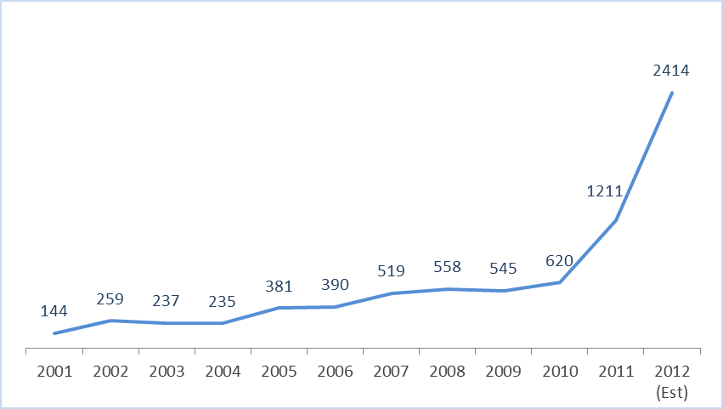
Source: http://www.hiretheworld.com/blog/employers/business-news/protecting-your-intellectual-property-from-patent-trolls

- Appendix B

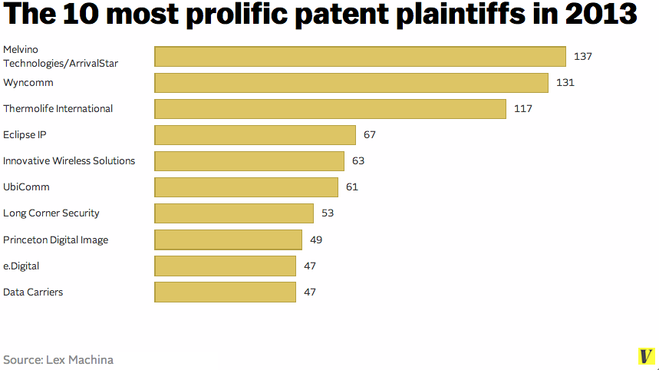
Source: http://www.vox.com/2014/5/28/5745770/the-patent-lawsuit-crisis-in-5-charts

- Appendix C

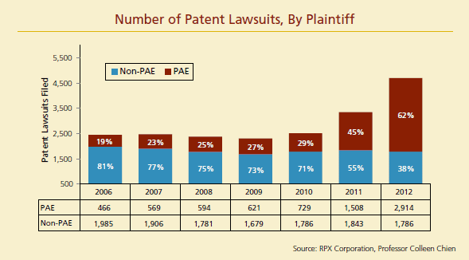
Source: http://www.triallawyersinc.com/updates/tli_update11.html

The Apple v. Samsung case will be discussed in detail in a later draft of this paper
See Chrysler Motors Corp. v. Auto Body Panels of Ohio, Inc., 908 F.2d 951, 952 (Fed. Cir. 1990).
See eBay, Inc. v. MercExchange, LLC (547 U.S. 388 (2006)).
See Apple Inc. v. Samsung Elecs. Co., Fed. Cir., No. 2013-1129, 11/18/13.
The casual nexus requirement is a result of eBay, and one that improved upon the four-factor test outlined in Chrysler Motors Corp.
35 U.S.C. § 283.
See "injunction." Merriam-Webster.com. 2014. http://www.merriam-webster.com (1 October 2014).
Chrysler Motors Corp. v. Auto Body Panels of Ohio, Inc., 908 F.2d 951, 952 (Fed. Cir. 1990).
Richardson v. Suzuki Motor Co., Ltd., 868 F.2d 1226, 1247 (Fed. Cir. 1989, cert denied, 110 S. Ct. 154 (1989).
This is no longer good law, as will be explained in detail in future sections of this paper.
Chrysler Motors Corp. v. Auto Body Panels of Ohio, Inc., 908 F.2d 951, 952 (Fed. Cir. 1990).
See Rosenberg v. GroovPin Corp., 81 F.2d 46 (Fed Cir. 1988).
See Hybritech Inc. v. Monoclonal Antibodies, Inc., 802 F.2d 1367 (Fed Cir. 1986).
Odetics, Inc. v. Storage Tech. Corp., 14 F. Supp. 2d 785, 794 (E.D. Va. 1998) aff'd, 185 F.3d 1259 (Fed. Cir. 1999).
eBay Inc. v. MercExchange, L.L.C., 547 U.S. 388, 390, 126 S. Ct. 1837, 1839, 164 L. Ed. 2d 641 (2006).
MercExchange, L.L.C. v. eBay, Inc., 275 F. Supp. 2d 695, 722 (E.D. Va. 2003) aff'd in part, rev'd in part sub nom. MercExchange, LLC v. eBay, Inc., 401 F.3d 1323 (Fed. Cir. 2005) vacated and remanded sub nom. eBay Inc. v. MercExchange, L.L.C., 547 U.S. 388, 126 S. Ct. 1837, 164 L. Ed. 2d 641 (2006) and judgment entered, 660 F. Supp. 2d 653 (E.D. Va. 2007).
Id. at 711.
MercExchange, L.L.C. v. eBay, Inc., 275 F. Supp. 2d 695, 712 (E.D. Va. 2003) aff'd in part, rev'd in part sub nom. MercExchange, LLC v. eBay, Inc., 401 F.3d 1323 (Fed. Cir. 2005) vacated and remanded sub nom. eBay Inc. v. MercExchange, L.L.C., 547 U.S. 388, 126 S. Ct. 1837, 164 L. Ed. 2d 641 (2006) and judgment entered, 660 F. Supp. 2d 653 (E.D. Va. 2007).
See MercExchange, LLC v. eBay, Inc., 401 F.3d 1323, 1339 (Fed. Cir. 2005) vacated and remanded sub nom. eBay Inc. v. MercExchange, L.L.C., 547 U.S. 388, 126 S. Ct. 1837, 164 L. Ed. 2d 641 (2006).
35 U.S.C. § 154(a)(1)-(2).
Patent trolls, or non-practicing entities, whose whole business model is acquiring and reselling patent rights, will be discussed later in this paper.
The length of term for a patent has changes several times over the years. Currently, patent holders may enjoy 20 years of protection from the time their patent application is filed, so long as the maintenance fees are paid on time.
This again is coming from a natural rights perspective of the patent law system.
This concept actually already exists. Websites like The Internet Wish List (http://www.theinternetwishlist.com) allow people with ideas to post them online, for anyone to look at and think about. Individuals with the resources and know-how necessary to actually carry out the invention may then copy idea, come up with a product, and sell the product.
Odetics, Inc. v. Storage Tech. Corp., 14 F. Supp. 2d 785, 794 (E.D. Va. 1998) aff'd, 185 F.3d 1259 (Fed. Cir. 1999).
eBay Inc. v. MercExchange, L.L.C., 547 U.S. 388, 391, 126 S. Ct. 1837, 1839, 164 L. Ed. 2d 641 (2006).
Monetary damages may be in the form of a reasonably royalty like that which would be awarded in the absence of a permanent injunction.
U.S. Code: Title 35.
Weinberger v. Romero-Barcelo, 456 U.S. 305, 307, 102 S. Ct. 1798, 1800, 72 L. Ed. 2d 91 (1982); See also Amoco, supra, at 542, 107 S.Ct. 1396.
eBay Inc. v. MercExchange, L.L.C., 547 U.S. 388, 391-92, 126 S. Ct. 1837, 1839, 164 L. Ed. 2d 641 (2006).
35 U.S.C. § 283.
35 USCA § 154.
eBay Inc. v. MercExchange, L.L.C., 547 U.S. 388, 392, 126 S. Ct. 1837, 1839, 164 L. Ed. 2d 641 (2006).
35 U.S.C. § 283.
See Id.
eBay Inc. v. MercExchange, L.L.C., 547 U.S. 92, 126 S. Ct. 1837, 1839, 164 L. Ed. 2d 641 (2006).
See Id. at 392-93; See also New York Times Co. v. Tasini, 533 U.S. 483, 505, 121 S.Ct. 2381, 150 L.Ed.2d 500 (2001) (citing Campbell v. Acuff–Rose Music, Inc., 510 U.S. 569, 578, n. 10, 114 S.Ct. 1164, 127 L.Ed.2d 500 (1994)); Dun v. Lumbermen's Credit Assn., 209 U.S. 20, 23–24, 28 S.Ct. 335, 52 L.Ed. 663 (1908).
eBay Inc. v. MercExchange, L.L.C., 547 U.S. 388, 393, 126 S. Ct. 1837, 1840, 164 L. Ed. 2d 641 (2006).
Mercexchange, L.L.C. v. eBay, Inc., 275 F. Supp. 2d 695, 712 (E.D. Va. 2003) aff'd in part, rev'd in part sub nom. MercExchange, LLC v. eBay, Inc., 401 F.3d 1323 (Fed. Cir. 2005) vacated and remanded sub nom. eBay Inc. v. MercExchange, L.L.C., 547 U.S. 388, 126 S. Ct. 1837, 164 L. Ed. 2d 641 (2006) and judgment entered, 660 F. Supp. 2d 653 (E.D. Va. 2007).
eBay Inc. v. MercExchange, L.L.C., 547 U.S. 388, 393, 126 S. Ct. 1837, 1840, 164 L. Ed. 2d 641 (2006)
See Id.
Id. at 394.
See Id.
As a side note, upon remand and after careful analysis using the four-factor test, the District court again issued an order to deny the injunction based on MercExchange’s history of attempting to license the patent. Mylene Mangalindan, WSJ Dec 13 2007 B4, "EBay is Ordered to Pay $30 Million in Patent Rift." On February 28, 2008 eBay released a statement saying that the parties had reached a settlement. http://www.mercurynews.com/business/ci_8403733.
“Patent Trolls” https://www.eff.org/issues/resources-patent-troll-victims
“Jerome Lemelson, Independent Inventor (1923-1997)”, Martha Davidson, http://invention.smithsonian.org/about/about_bio_jerome.aspx
See Appendix A
Data from Pat Stats (http://www.patstats.org/Injunction_rulings_post-eBay_to_5-26-2013.xls) through May 26, 2013.
“ Happy 5th Anniversary: The Impact of eBay v. MercExchange”, Gene Quinn, http://www.ipwatchdog.com/2011/05/15/happy-5th-anniversary-ebay-v-mercexchange/id=16894/.
See appendix A.
See appendix B.
See appendix C.

